Practice-It and Graphs

Go to the Practice-It website at: http://practiceit.cs.washington.edu/

After you log in, click on Start Practicing!

Select University of Washington CSE 373

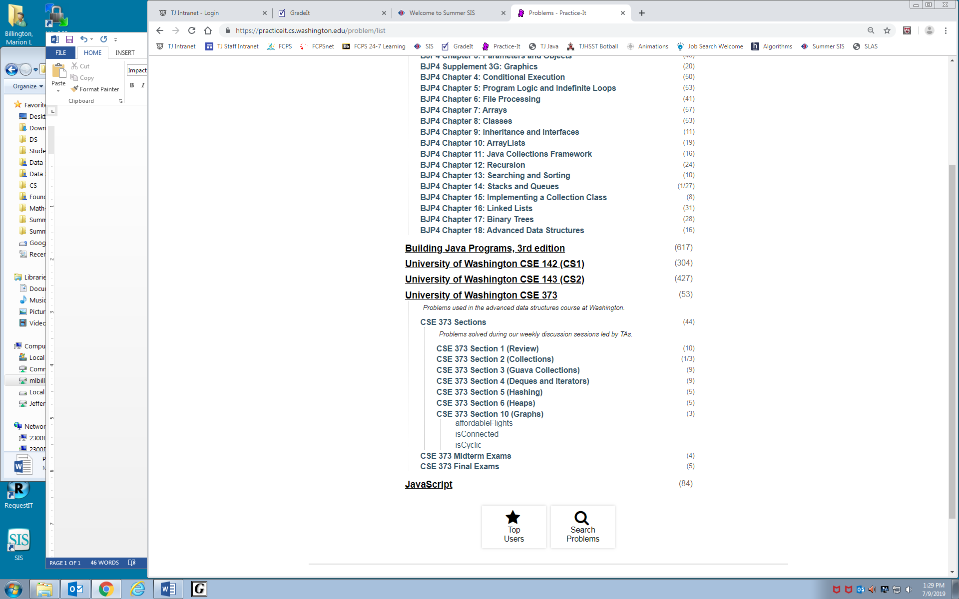
Select CSE 373 Sections

Select CSE 373 Section 10 (Graphs)

Your assignment is to solve all 3 problems.

